

Nombre de la Unidad: | WHO AM I?
Nombre de la Asignatura: | INGLÉS BÁSICO 1

SEMANA 2 / ACTIVIDADES

Aprendizaje Esperado

- Categorizar nacionalidades en inglés según países y sufijos.
- Utilizar el verbo TO BE en su estructura afirmativa, negativa e interrogativa.

INSTRUCCIONES GENERALES

Estimado(a) estudiante:

- Una vez realizada la lectura comprensiva del material de estudio de la semana, te invitamos a realizar una serie de actividades de aplicación de conocimientos.

- Puedes recurrir a fuentes de información segura en Internet. En este caso debes declarar las referencias.

ACTIVIDAD 1

- Write the nationality for each country
Country | Nationality | Country | Nationality
- Australia |  | - Poland
- Japan |  | - Thailand
- Britain |  | - France
- The United States |  | - Portugal
- Italy |  | - Lebanon
- Turkey |  | - Egypt
- China |  | - Netherlands
- Spain |  | - Switzerland
- India |  | - Ireland
- Vietnam |  | - Israel

ACTIVIDAD 2

- Categorize the nationalities according to their suffixes

-n, -an, -ian | -ese | -ish | other

ACTIVIDAD 3

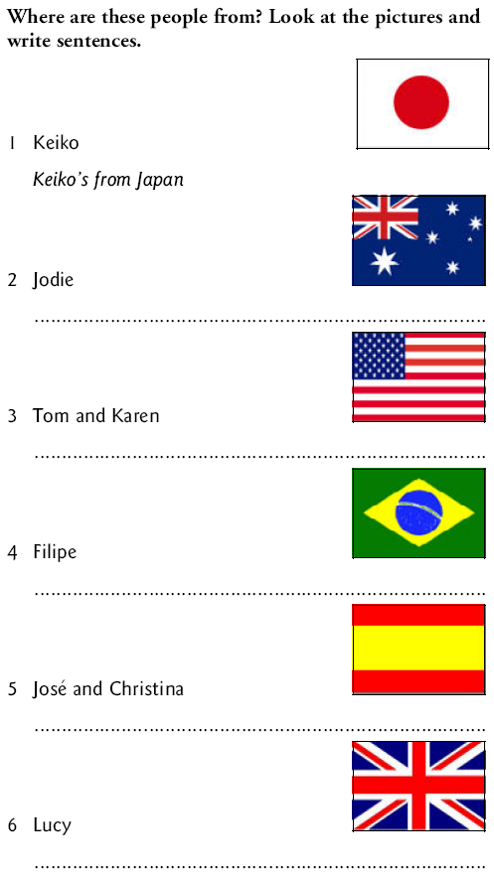

ACTIVIDAD 4

VERBO TO BE

- Completa los espacios con el verbo to be: “am”, “are” o “is”, según corresponda.

1. My sister ________ beautiful
2. My brother and I _________ in the basketball team
3. My cat _________ in the garden
4. My friends ________in the party
5. My teacher _________ very intelligent
6. Thalía _____ a famous Mexican singer
7. Hugo and Paco ______ brothers
8. The restaurant __________closed

- Complete las oraciones. Use la forma contraída del verbo TO BE.

1. _________ at school. (We are) | 8. _________ here. (He is)
2. _________ in the classroom. (You are) | 9. _________ from Mexico. (She is)
3. _________ in Room 5. (They are) | 10._________ the capital of Texas. (It is)
4. _________ married. (I am) | 11._________ here today. (She is)
5. _________ at work. (He is) | 12._________ at home. (He is)
6. _________ a student. (She is) | 13._________ married. (They are)
7. _________ in the classroom. (I am) | 14._________ from China. (They are)

ACTIVIDAD 5

Make questions from the following statements.
Example: He is happy. – Is he happy?

- John is from England. ________________________
- Mary is in Concepción. _________________________
- Adam and Anna are married. _________________________
- He is at home. _________________________
- She is at school. ________________________
- They are at work. ________________________
- This apartment is small. ________________________
- The students are at school. ________________________
- He is in the classroom. ________________________
- The book is on the desk. ________________________
- They are on the table. ________________________
- The students are from India. ________________________
- The door is open. ________________________
- The child is at home. ________________________

ACTIVIDAD 6

Make negatives from the following statements.
Example: He is my friend – He isn’t my friend

- We are at school.
- You are in the classroom.
- They are in Room 5.
- I am married.
- He is at work.
- She is a student.
- I am in the classroom.
- He is here.
- She is from Mexico.
- It is the capital of Texas.




